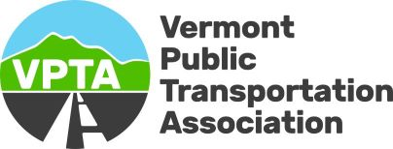

160 Benmont Avenue, Suite 11, Bennington, Vermont 05201 | (802)442-0629| [www.vpta.net](http://www.vpta.net)

**Program Trainer Job Posting**

August 27, 2024

Agency Name: Vermont Public Transportation Association

Full-Time – Benefits Available

Official Title: Program Trainer

Office Location: Bennington, VT

Position Reports To: Executive Director of Vermont Public Transportation Association

Description of Work:

VPTA seeks a highly motivated candidate to support Vermont public transportation providers with program training and assessment, including the Vermont Medicaid and Older Adults & Persons with Disabilities Transportation programs and other programs as needed. This will include developing training and assessments, onsite training throughout the state, and continued support with quality assurance.

Essential Duties and Responsibilities:

We provide essential transportation services that increase the mobility of our fellow Vermonters through multiple programs that include access for seniors, people with disabilities, veterans, and Medicaid-eligible individuals. The core responsibilities are as follows:

• Develop and provide training and assessments related to transportation programs and best practices.

• Foster partnerships among key stakeholders.

• Serve as a resource to the transportation providers and their staff to ensure contract compliance.

• Attend meetings with key contractor holders (DVHA and VTrans) to implement programmatic changes as needed.

• Perform other duties as assigned.

Experience:

Experience in a training environment is desirable but not required. Experience in compliance preferred. Candidates must demonstrate a clear interest in or a working knowledge of supporting public transportation.

Qualifications:

• Bachelor’s Degree or equivalent experience

• Excellent verbal and written communication skills, presentation skills, tact, and diplomacy

• Ability to plan, organize, and prioritize; coordinate complex tasks and activities; and work independently and in a team environment.

• Willingness to travel around Vermont to meet with stakeholders in all regions.

• Proficiency in Microsoft Office suite

Application Process:

• Interested applicants should submit a resume and cover letter to the Vermont Public Transportation Association office by the due date.

• Applicants must pass all background checks and have a valid driver’s license.

Salary Range 55-60k